- jo@investigator.demo & co@investigator.demo
- Port 3389 is used to block RDF traffic. Pin 172.18.0.1
- 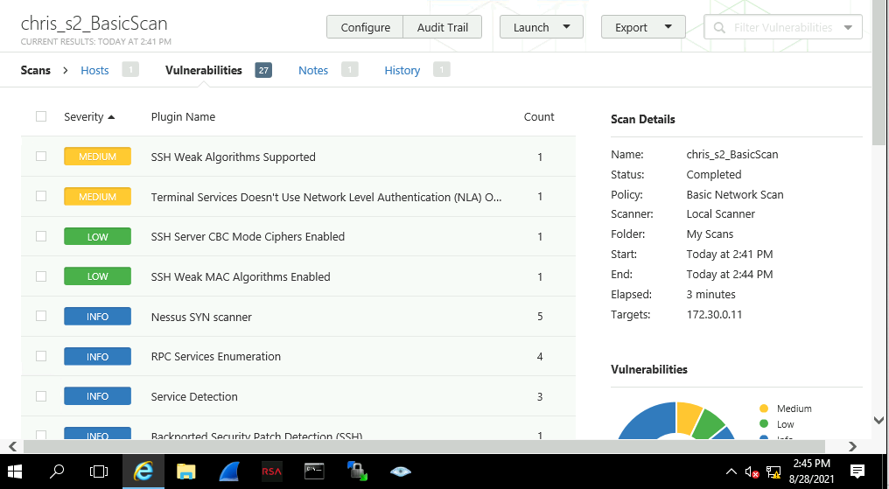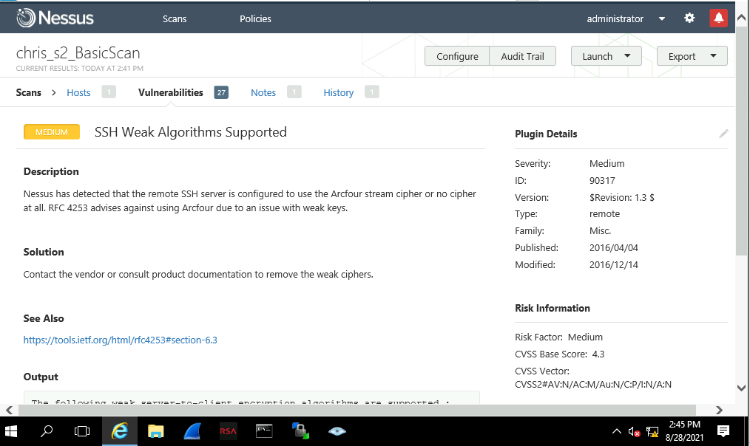To fix the issue above, is by using a different stream cipher, as Arcfour brings a medium level vulnerability, this cipher must be removed.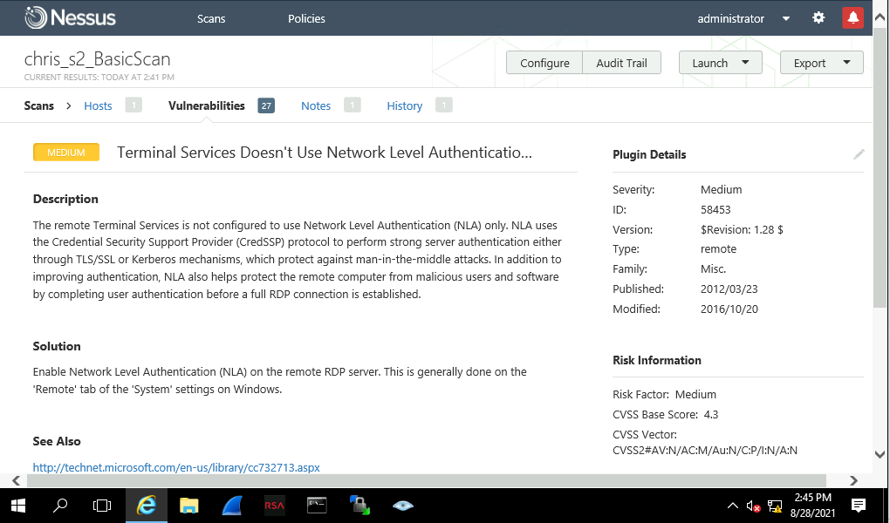
The terminal must be able to use Network Level Authentication, without this NLA, the server is open for man-in-the-middle attacks, as there is no protection to prevent this leak.

